OUR STAFF  Our Summer Camp employs the current teachers of Serenity Montessori Academy. The owner, Sarah Colucci has over 27 years of experience as a Montessori educator and Camp Director in Millburn and Oak Knoll School’s Summer Adventure Program in Summit ,NJ. Antoinette Barbato , has a 25 year tenure as a primary and secondary school educator in Verona schools. The children highly benefit from experienced teachers that are already familiar with the children’s personalities and needs which in turn, will provide a secure and nurturing environment for children to develop new friendships and become curious learners. Our staff members are energetic, creative and careful when planning the summer curriculum. The themes transcend all age groups and lessons are presented in an age-appropriate level of comprehension. The ultimate goal is to allow the children to explore, develop a sense of wonder and increase their knowledge and vocabulary within the context of our themes.  *Our Staff members are CPR and First Aid Certified. |  |  |  |  |  |  | Camp Hours  Half Day -9:00am-11:30 am  Full Day -9:00am-3:00pm  3,4 or 5 day schedules available  Sibling discounts, referral discounts  *Extended Morning Care *  7:45am-9:00am  Additional fees apply  *After Care*  Available upon request  Additional fees apply  For more information on  the program, availability  and pricing …  Contact:  Sarah Colucci-Owner/Director  serenitymontessori@gmail.com  973-239-3902 |  |  |  |  |  |  |  | 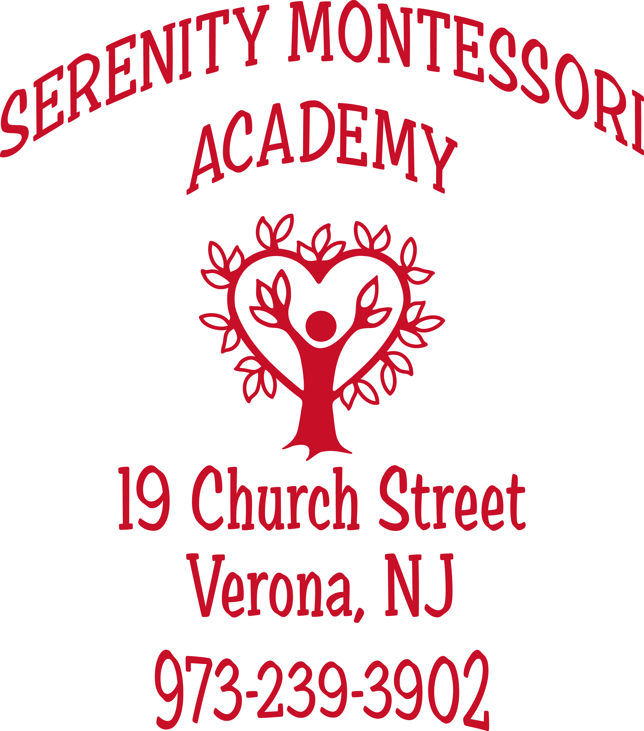 |  |  | Serenity Montessori Academy presents:  Is  - SERENITY SUMMER ADVENTURES CAMP  - 19 Church Street  - Verona, NJ 07044  973-239-3902  June 25-Aug.17  Flexible schedules, full and half day program, sibling discounts, 2.3 yrs. old welcome!  - June 26- Aug. 25  Ju
HAVE YOU MADE SUMMER CAMP PLANS  FOR YOUR CHILD?  ABOUT US  Serenity Summer Adventures Camp allows children from 2.3yrs.-6yrs.old to continue the process of learning using exploration and curiosity to develop higher levels of cognitive thinking. All children are actively involved in increasing their communication skills, sharing with others and working with a variety of age groups in harmony. Outdoor play is incorporated into the daily activities and diversified within the weekly themes. Camp activities include:  - _{Crafts/recyclable art}  - _{Painting/face painting}  - _{Cooking skills}  - _{Sand/water play}  - _{Drama/dress up}  - Group games/ music and movement  - _{Wading pools/sprinklers}  - _{Dramatic play areas}  - _{Special Event’s Fridays}  - _{Nature adventures}  - _{Bounce House Event}  - _{Special Community Visitors}  - _{Kona Ice Day}  - _{Summer Camp Special Visitors}  - _{Music and Movement}  Phone: [Telephone]  Email: [Email address]  Web: [Web address] |  |  |  |  |  |  |  |  |  | *We enroll children from the entire community. Bring a new friend and have a spectacular experience this summer! Graduating children welcome!  CAMP THEMES  June 25-Aug. 17  Wk. 1 June 25-29 Artistic Creations  Wk.2 July2-6(not 4th) Red,White & Blue  Wk.3 July 9-13 Going Green!  Wk .4 July 16-20 Holiday Adventures  Wk .5 July 23-27 Rainforest Cafe  Wk.6 July 31-Aug 4 Summer’s Garden  Wk.7 Aug 6-10 Incredible Athletes  Wk.8 Aug 13-17 Community Helpers  *additional $100 off will be given you enroll for 8 weeks of camp*  *$50 off if you enroll by March 15! |  |  |  |  |  |  |  |  |  | The children at Serenity Summer Adventures Camp are provided with a safe, healthy and nurturing environment where they continue to understand and accept the trust of their teachers. We provide physical activities that support large and small motor movement and support their social- emotional development through positive guidance and interactions. We use the summer camp weekly themes as a guideline in presenting new objects and new vocabulary through word/ object associations. We achieve this through the use of tactile activities involving the five senses.  Toddler Camp Program  ( 2years 3months -3years old)  Our young campers will learn about the world around them and discover a sense of independence, confidence and curiosity through a variety of planned indoor and outdoor activities. They will enrich their vocabulary, communication skills and their wonder about the world around them. They will continue to learn through a variety of age appropriate activities using crafts, paint, group games and music to enhance their day.  Preschool-Kindergarten Camp Program  ( 3.6 yrs. old - 6 yrs. old )  Created with young campers in mind, our camp offers a wonderful opportunity for children 3yrs.-6yrs. to experience fun summer days filled with creative activities using their five senses. Your child will benefit from the experienced teaching staff and planned daily activities and outdoor playtime. It a great opportunity to meet new friends and bond with the children that will be your classmate in September.  Summer Camp Fees  Half Day 9-11:30am or 12:30pm -3pm………$145/wk  3 days/wk Am or PM session……$95  Full Day 9am-3pm…$ 220 * 3 full days…..$175  Extended Morning Care 7:45am- 9am……….$ 10

